**Pollen Grains Separation**

**1. INTRODUCTION**

1.1 Project Overview

The project "Pollen Grains Separation" aims to design a method for effectively separating pollen grains from flower samples using scientific techniques and filtering mechanisms. The goal is to enhance accuracy in botanical studies, allergen research, and agricultural applications.

1.2 Purpose

The purpose of this project is to develop an efficient, scalable, and user-friendly method to isolate and collect pollen grains for analysis and experimentation in fields like botany, medicine, and environmental science.

**2. IDEATION PHASE**

2.1 Problem Statement Manual pollen separation is tedious, inaccurate, and time-consuming. An automated or semi-automated process is required for precision, speed, and usability in laboratories and research facilities.

2.2 Empathy Map Canvas

- Who? Botanists, researchers, students, farmers.

- Needs? Fast, precise pollen collection.-

Pain Points? Time-consuming, contamination, lack of tools.

- Goals? Clean separation, better analysis, and automation.

2.3 Brainstorming

**Ideas included:**

Use of sieves with different mesh sizes

- Centrifuge-based separation

- Electrostatic attraction

- Filtration with airflow control

- Microscopy-assisted manual collection

**3. REQUIREMENT ANALYSIS**

3.1 Customer Journey Map

Identify flower sample -> Process through filtration/sieving system -> Collect pollen -> Analyze under microscope -> Document results

3.2 Solution Requirement

- Fine mesh filters

- Vacuum chamber or suction mechanism

- Microscopic imaging setup

- Sample containers and labeling

3.3 Data Flow Diagram

Input (flower sample) -> Filtration unit -> Pollen collector -> Storage container -> Microscopic analysis

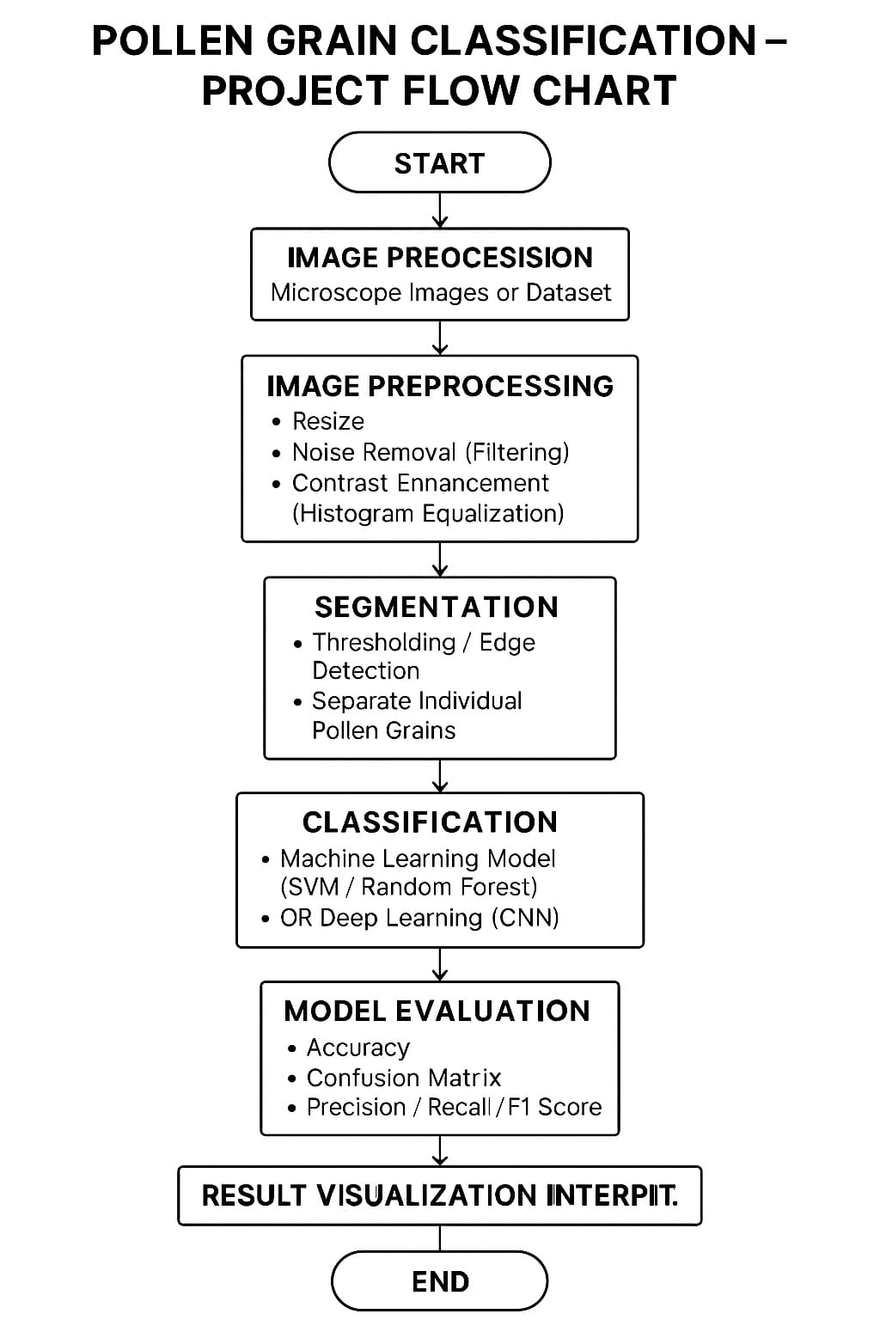

3.4 Technology Stack

- Mechanical components: filters, tubes, vacuum pump-

Imaging: Microscopes with camera

Software (optional): ImageJ for pollen size analysis

**4. PROJECT DESIGN**

4.1 Problem-Solution Fit

Provides a practical method to quickly isolate pollen with minimal contamination and manual effort.

4.2 Proposed Solution

A pollen separation unit using fine mesh filters and vacuum suction